Year R Autumn Term 2
3rd November 2023
Curriculum Newsletter

Dear families

Thank you very much for supporting us in settling your children. It has been lovely to see them starting their school journey with growing independence. During this half term we will continue to reinforce the school routines and build on the children’s confidence within the setting and developing friendships.

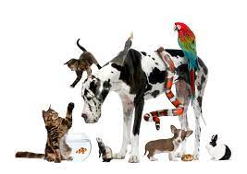
Our first topic this half term is ‘Pets’. During this topic we will be looking at different types of animals and thinking about how we care for them. We will be discussing pets we have or would like to have and reading lots of stories all about pets. We will be introducing a toy pet to our role play and creating lots of stories about them in Tales Toolkit time.


Our last topic of the Autumn Term is ‘Christmas’, where we will learn about the Christian Christmas Story. We have lots of festivities that we celebrate this half term such as Diwali, Bonfire night and Christmas. We are very excited about all the festive activities we will do in school.


In our daily phonic sessions we are learning letter sounds and the formation of each letter shape. Keep using the letter formation sheets to practise the sounds at home. Alongside sound recognition, we are teaching the children how to put letters together to read simple words (blending). Please continue to read three times a week with your little one. We must stress we absolutely need the books returned on the Thursday each week. This ensures the programme can run effectively for all children. Alongside our blending focus we are learning to recognise and practise our tricky words too, these are those words that can’t be sounded out and need to be learnt by sight. We will be using all of our sound knowledge to build and write CVC words too, we will segment each sound and use a phoneme frame to help us.

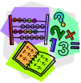
In maths we will continue to practice our 1:1 correspondence for accurate counting. We are focussing on the correct number formation and supporting the children to cement this understanding on the number from 1-3. We will be using our number rhyme to practise writing our numbers. Please continue to practise to recognise numbers by sight in and around the children’s environments at home. They will be learning the skill of comparing numbers by beginning with the concepts of more, less and equal. We are learning to recognise and name our 2D shapes. Can they spot a circle, triangle, square or rectangle in their home or when out and about?

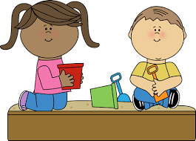
The children are particularly enjoying our M.O.O.T (Managing Our Own Time) sessions, which encourage them to use their new learning environment with greater confidence and develop their independence skills, problem solving, cooperation and creativity. M.O.O.T takes place five times a week and allows the children to plan and undertake their own learning from a wide range of activities available. During this time the adults support the children by scaffolding or extending their learning. They will also identify children who are off track in an area and develop the learning.


We would also really appreciate it if your child has a coat in school at ALL times as we use our outdoor classroom in all weathers and therefore we really need the children to have the correct clothing. We do not mind if they have one they leave at school if they do not like to wear it in the mornings.

Thank you for all the support you are offering your children at home with their learning. As always, please remember if you have any concerns or queries, please do speak to your child’s class teacher at the end of the school day.

Yours sincerely,

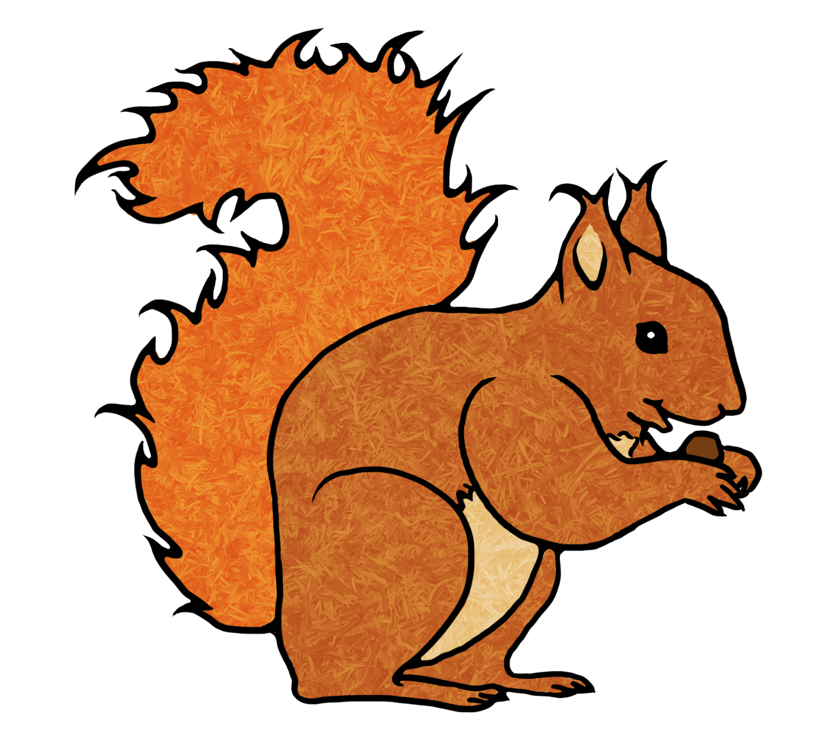
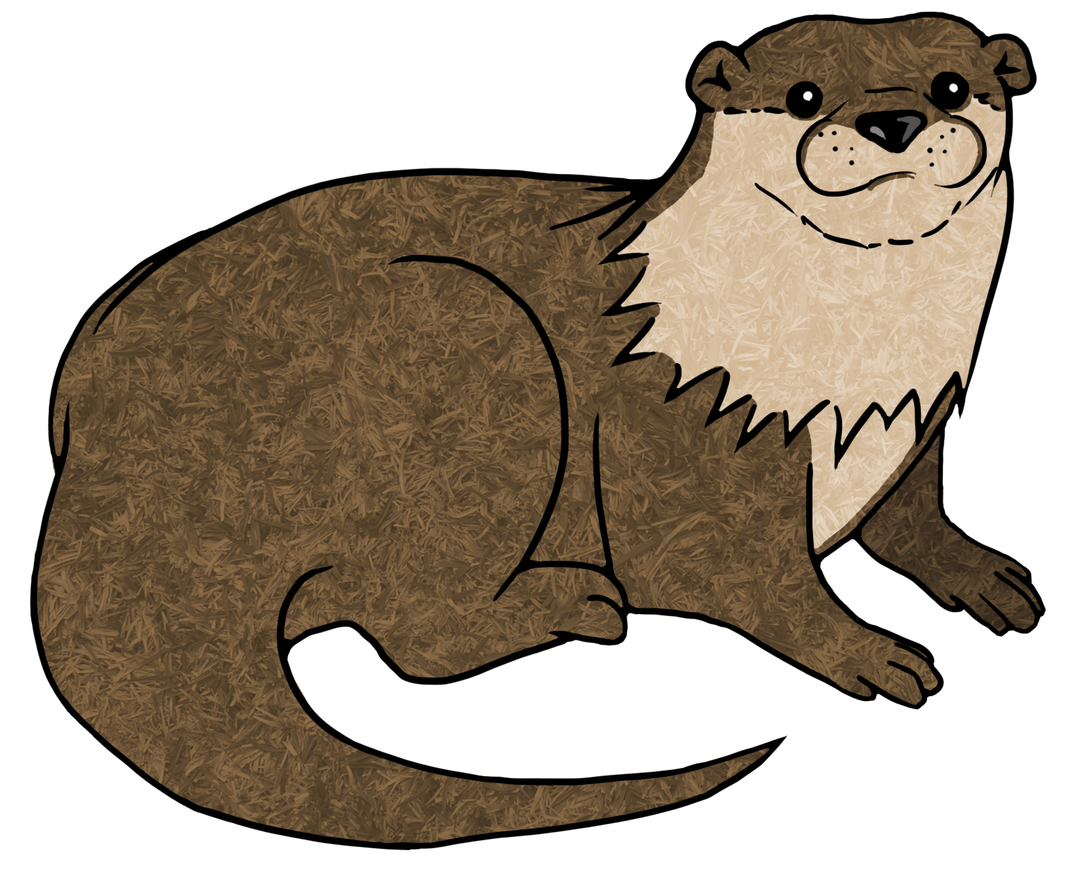
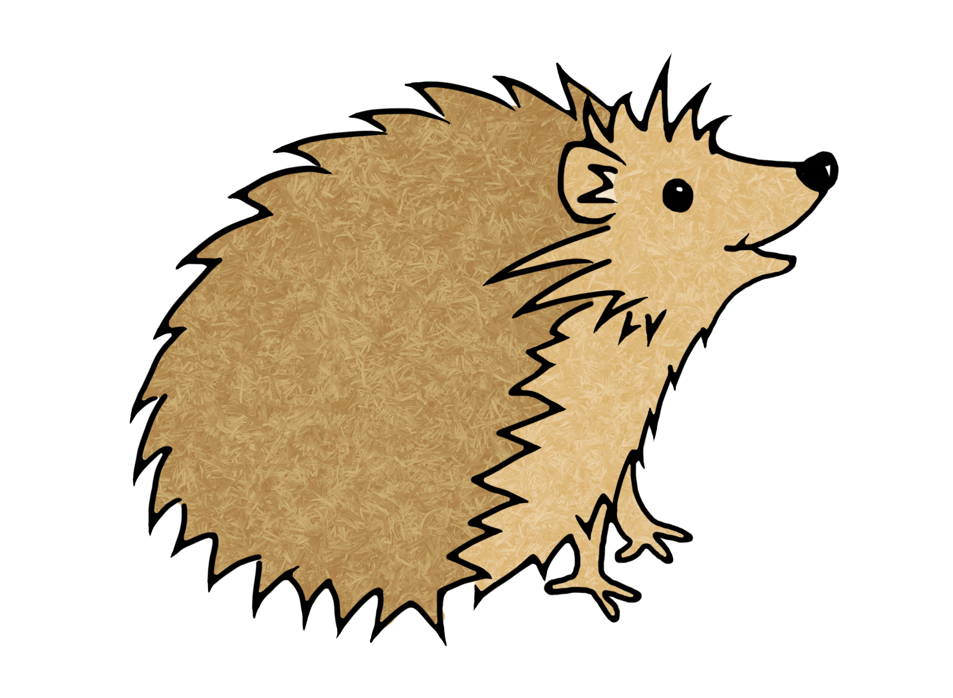
Abby Sneddon Georgia Channell Mel Arnott Cate Gregory Squirrel Class Otter Class Hedgehog Class Early Years Leader

