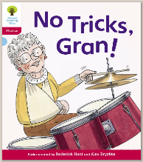
Oxford Owl – Blue
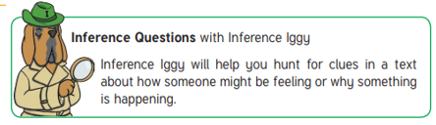
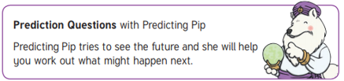
No tricks, Gran by Roderick Hunt

This is a good example of a book for inferring and predicting what might happen. Try exploring the two reading strategies when sharing the book with your child.
Common exception words in the text:
Said, like, were, come, what, one

Questions:
- Look at the front cover.
Can you predict what kind of trick Gran will play? Can you explain your prediction?

- Page 2
Why do you think the children were glad Gran came? How do you feel when you get visitors to your house?

- Pause at page 3
How do you think Gran hurt her arm? Read the next page and see if your prediction was correct.

- Pause at page 6-7
What could be in the box? Have you ever seen a box that big before?

- Page 9
Look at Dad. What does he say? How do you think he is feeling? How do you know?

- Page 10
Why was Dad strict with Gran?

Challenge: There are lots of words in the text using the /igh/ trigraph. Can you think of lots more words with the /igh/ sound in them? What about words using the other trigraphs /air/ ure/ ear?

