Parents
We have taught the children about writing in the present tense and the past tense. When writing sentences in the past tense, children need to find the verb and add the -ed suffix when there is no change to the root of the word. e.g. look- looked. Please remind children what they have learnt and then ask them to complete the sheet below. Thank you!

Can you add in ed?
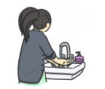
1. Jane wash____ her hands

Can you add in the word with the ed suffix?
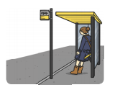
2. Polly _______ for the bus.
wait

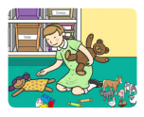
pick
3. Lynne _______ up her toys.
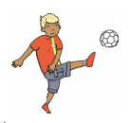
kicke
4. Ben _______ his football.


5. Sam _______ a hot drink.
need

Can you write your own sentences for these pictures?

brush

____________________________________________________________

licke

__________________________________________________________________________________________

Challenge
Look at adding ed to these words. What do you notice? You may wish to look for other verbs in books and make a list.
created
create
shade
dance
use
love

I noticed…______________________________
_____________________________________________________________________________________________________________________

