Parents
The children have been focusing on adding the –ed suffix to verbs. We use the –ed suffix when we are writing/ talking about things that we did in the past, not the present.
Remind the children that verbs are words which describe an action. These are “doing” verbs. We help children recognise verbs by asking them if we can act them out. For example, “Can you show me walking? Yes! walk is a verb. Can you show me yellow? No yellow is not a verb.”

Oops! Miss Ruck has made 3 mistakes in her writing below. Can you spot the words that should have -ed at the end of them?
Yesterday in the morning I walk round the park with my family. When I look up to the sky I could see the beautiful, yellow sun shining down. In the park, there was a tree that had fallen down! I jump over the tree. It was a bit scary!

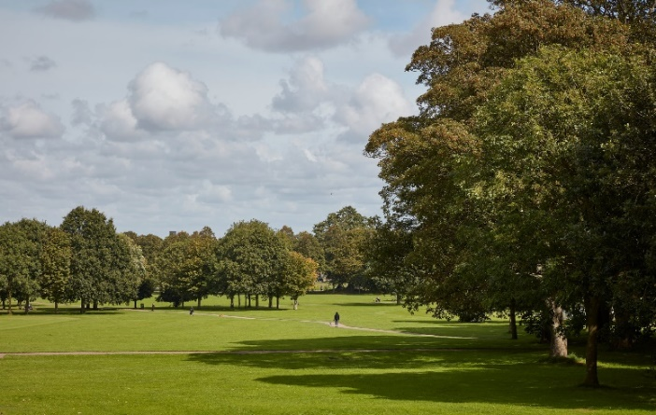

Can you write 4 sentences about your day yesterday? Make sure you don’t make the same mistakes as Miss Ruck!
___________________________________________________________________________________________________________________________________________________________
_______________________________
_______________________________

Challenge
Can you write a short story which has all these words written in the past tense?
look call love walk laugh dance jump ask
Extra
- Match the verb to the right past tense. This is tricky! https://www.gamestolearnenglish.com/past-tense-game/
- Game and quiz https://www.bbc.co.uk/bitesize/topics/zrqqtfr/articles/z3dbg82

