Year 1 Reading Activities
Over the next few weeks, we have put together a range of reading activities for you to complete with your child at home.
The books that we have based the questions on can be accessed on the following website:
https://www.oxfordowl.co.uk/
To gain access to the books we have planned for you, please follow the instructions below:
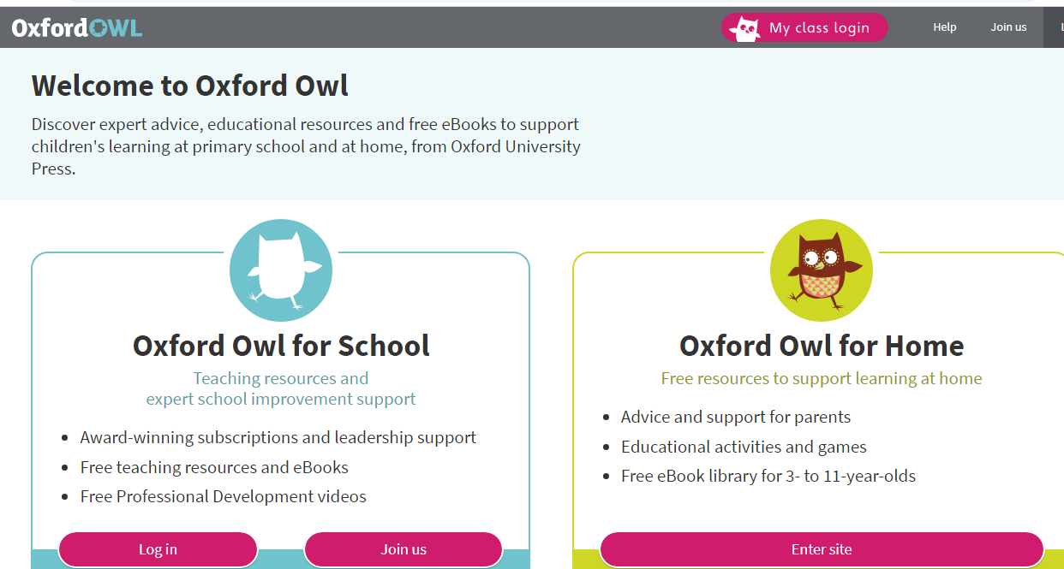
- Click on the My class login.
Class login details: Please login in using your child’s class name (case-sensitive)
SIowls
SIrabbits
SImoles
Password for all: Shirley1
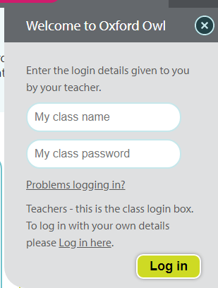

3. Click on My bookshelf
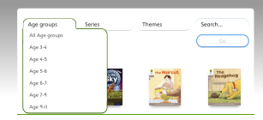
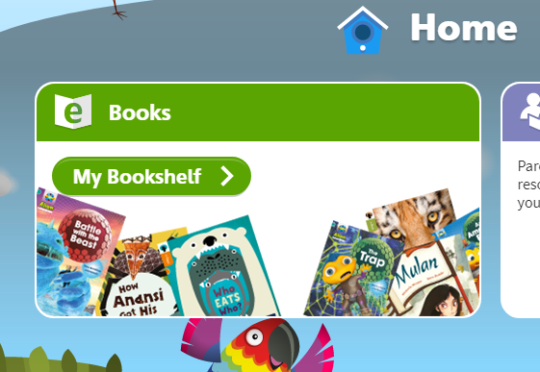

Each book chosen by the Teachers will have a page of supported questions available to help you guide your child through each text. The Oxford Owl website also has interactive games and questions in addition to the guides set by school. Have fun!

