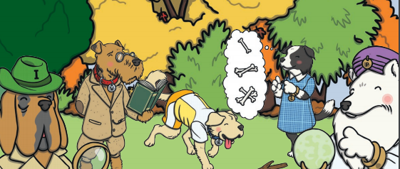
Reading Questions
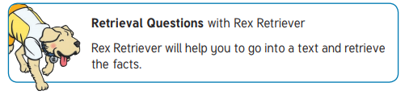
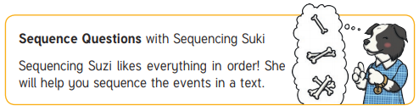
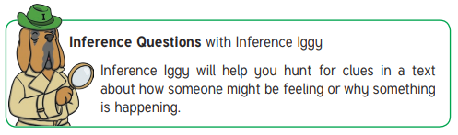
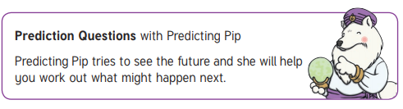
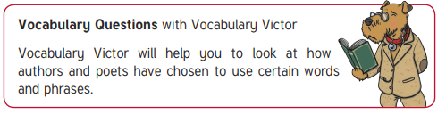

These are the reading dogs we use to aid the children’s reading skills. Have a look below at our friendly set of canine helpers who ask different types of questions about what they have read.

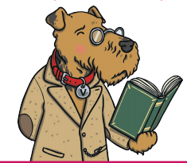
Pick a dog to focus on with your child when you are reading and then choose some questions.
Vocabulary Victor questions
- Why do you think the author used the word…?
- Can you find a word in the text which means the same as…?
- Find an adjective in the text.
- How/where can we find out the meaning of this word?
- Can you find a word/sentence that tells you/shows that…?
- Can you read around this word to have a guess at what it means?
- Which words has this author used to make you feel happy/angry/worried/frightened/nervous.
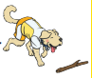
Rex Retrieval questions
- Where is this story set?
- When is this story set?
- Is there a good/bad character? Who is it? How can you tell?
- How does the story end?
- Which is your favourite/worst/funniest/scariest part of the story? Why?
- What happened to make…?
- Can you think of a different title for this story/poem/text/section/chapter?
- Tell me three facts you have learnt from the text.
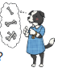
Sequencing Suzi Questions
- What is happening at the beginning?
- Who do you meet first?
- What did you find out first?
- Put these sentences in the order they happened…
- What happened next/in the middle/at the end of….?
- Draw a picture to show what happened in the beginning/middle/end.
- Write a sentence to show what happened in the beginning/middle/end.


Inference Iggy Questions
- What do you think … is saying/thinking/feeling at this point? Why?
- Why does the author use the word … here?
- What do you think the word … means? Why do you think that?
- Can you explain why … ?
- Why/where do you think …?
- Which bit made you feel happy/sad/scared/excited? Why?
- How did you feel when …. ?
- What can we guess about where/when this is taking place?
- Is there anything you’ve just read which reminds you of something that has happened to you, or someone you know? Why? How?

Predicting Pip Questions
- What do you think will happen next?
- Where do you think …. Will go next?
- What do you think … will say/do next?
- How do you think this will end?
- Can you think of any other stories that start like this? How do they end? Do you think this will end the same way?
- What sentence do you think will come next?
- Draw what you think is going to happen next.
- Write three questions you would like to find the answer to in this text.
- What could happen if …. ?

Suggested books

