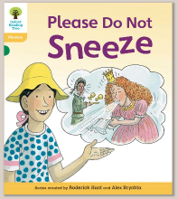
Oxford Owl – Green
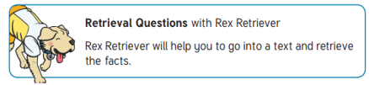
‘Please do not sneeze’ by Roderick Hunt

We encourage children to use the pictures to support their reading and comprehension but also expect that they will be able to find the text to prove they are using their Retrieval skills.
Common exception words in the text:
There, people, looked, called

Questions:
- Page 1
Was the sea warm or cold? Which word describes how the sea felt?

- Page 3
How were the children feeling? Why did they feel like that?

- Page 5
What were the children called?

- Page 7
What did Anneena do to help the children?

- Page 8
What was Princess Sophie’s problem? Can you make a list of all the funny things Princess Sophie’s sneezes sound like?

- Page 11
Why was the Queen cross?

- Page 21
Why do people sneeze a lot?
Challenge: How many different ways can you make the /ee/ sound? Can you write a list of words using the following alternative pronunciations?
ee | ea | ey | e-e | ee-e
sheep | tea | key | swede | sneeze

