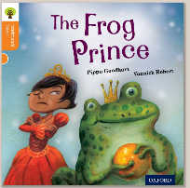
Oxford Owl – Orange
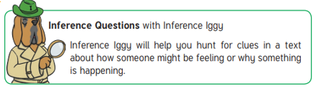
‘The Frog Prince’ by Pippa Goodhart

Vocabulary to discuss
Promise, precious, easy, friends

Questions:
- At the beginning of the story can you describe the Princess?
What type of Princess was she? Kind, mean, shy, friendly, spoilt? Give me some reasons for your answer.

- Page 5
Why did the Princess cry?

- Page 7
Why do you think the Frog ‘has no need for a crown’?

- Page 8-10
How do you think the Frog was feeling when the Princess ran away?

- Page 12
Why didn’t the Princess want them to open the door?

- Page 19
How did the Prince feel when he changed from the Frog back into a Prince? What do you think the Princess wanted to say to him when this happened?

- When finished, think about the following questions…
What does a ‘real friend’ do?
What does ‘a promise is a promise’ mean?
Challenge:
Have you ever been a ‘real friend’ to somebody? Can you make a picture of you and your friend and label it with the qualities you need to be a good friend? For example; kind, helpful, funny….

