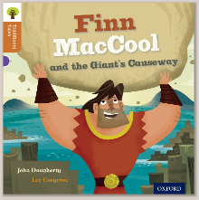
Oxford Owl – Purple
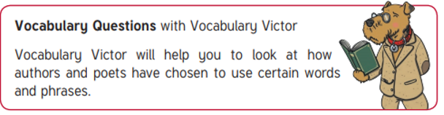
‘Finn MacCool’ by John Dougherty

Vocabulary to discuss
Bellowed, boast, roared, shouted, replied

Questions:
- Before reading the book
Can you talk about the vocabulary above to replace the word ‘said’? Encourage your child to look out for those words in the book and try and use some expression when reading. Why do you think the author used those words?

- Page 2
Can you remember what an adjective is (a describing word)? What adjectives did the author use to describe Finn MacCool?

- Page 3
What adjectives did the author use to describe Angus? Are they similar or different?

- Page 15
Why is the word ‘heaved’ repeated in the sentence? What effect does it have on the story?

- Page 16
Why was Finn worried?

- Page 18
Do you know what ‘Angus’ face fell’ means?

- When finished ask your child to choose their favourite page/ phrase in the book and explain why they like it.
What particular words did you like? Can you encourage your child to use some of those new words in everyday life?

Challenge:
Do you think Finn MacCool really made the Giant’s Causeway? Why/ why not?

