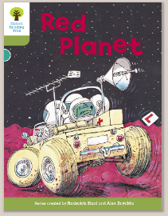
Oxford Owl – Turquoise
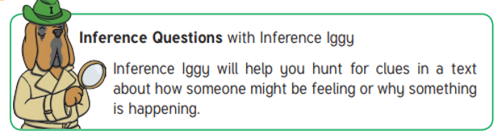
‘Red Planet’ by Roderick Hunt

Vocabulary to discuss- contractions
Didn’t, won’t, don’t, we’ll, it’s, I’m, wouldn’t, there’s

Questions:
- Before reading the book
Can you talk about the contractions above and how they are two words joined together? This makes the reading ‘flow’ more naturally. What two words make up the word didn’t (did and not), we’ll (we and will) etc… What does ‘won’t’ mean?

- Page 3
What would you do if you were pretending to be an astronaut/ spaceman?

- Page 6
Do you know anything about the Red Planet? Is there a real Red Planet (Mars)?

- Page 9
Why didn’t Chip want to go inside? How would you feel if you were there?

- Page 10
What do you think Floppy want to do when he presses the button?

- Pages 14 - 15
How are the characters feeling when they land on the Red Planet?

- Page 17
Why do you think it might not be safe to go outside?

- Page 21
How would you feel if you crash landed into the cave?

- Pages 23 – 26
Do you think the aliens are friendly? Why do you think this?

