Mental Maths
30 ÷ 5 = 2 x 7 =

21 + 29 = 40 – 10 – 10 =

33 + 28 = 62 – 30 =

This week’s Maths focus is: Addition
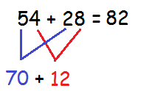
Here is a reminder of some methods that you could use to support your working.
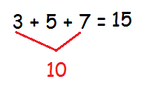

27 + 27 = | Gemma buys a magazine for 67p and a lolly for 19p.  How much does she spend altogether?
47 + 5 =
9 + 8 + 5 =
Here are some 2D shapes.  How many sides are there altogether?  Can you write the addition number sentence?  ______________________ | How many different ways can you make 47p?
It was Jim’s birthday. His aunty gave him £10 and his parents gave him £30.  How much money did he get in total? | How many different ways can you make 47p?
18 + 52 = | How many different ways can you make 47p?
36 + 43 = | How many different ways can you make 47p?
8 + 8 + 4 = | How many different ways can you make 47p?
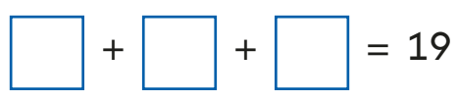
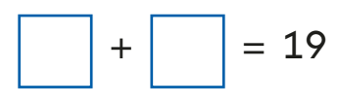
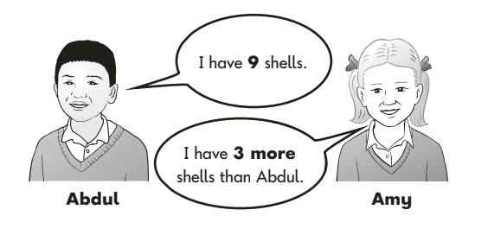
How many shells does Amy have?
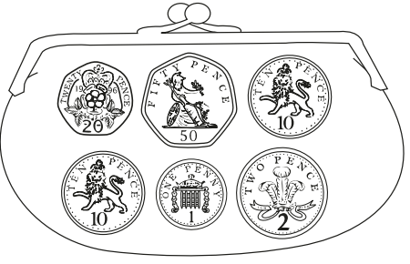

This is Sam’s purse.
How much money is there altogether?


Challenge: I can reason about addition
Professor Bob thinks that the statement below is true. Is he correct? Prove it!
The sum of three odd numbers will be odd. | Prove it using odd numbers
Is the Professor right?

