Over the next few weeks, we have put together a range of reading activities for you to complete with your child at home.
The books that we have based the questions on can be accessed on the following website:
https://www.oxfordowl.co.uk/
To gain access to the books we have planned for you, please follow the instructions below:
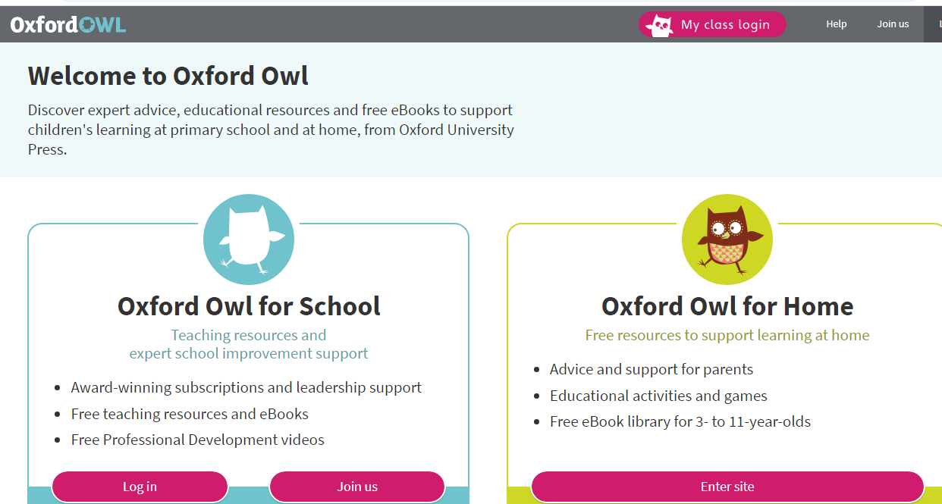
- Click on the My class login.
Class login details:
Please login in using your child’s class name (case-sensitive)
SIwoodpeckers
SIfoxes
SIbadgers
Password for all: Shirley1
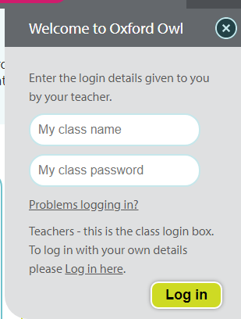

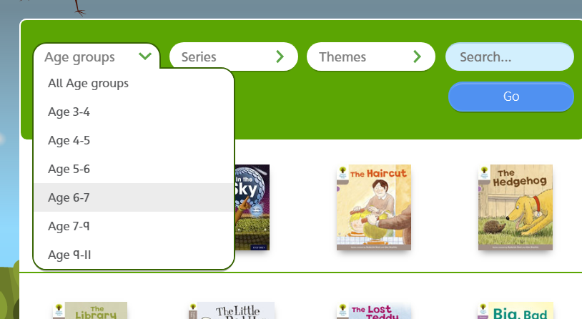
- Click on My bookshelf


