Reading at home – Year 2!

At school your children use the 5 dogs below to help them with their reading. Each of the dogs focus on a different skill:
Iggy – Inference
Pip – Prediction – what is going to happen next?
Victor – Vocabulary – particular words, what they mean and why the author might have used them!
Suki – Sequencing – knowing the order of events within a book.
Rex – retrieval – finding information and facts in the text.

When you are reading with your child try and choose one of the dogs and ask some of these questions throughout!
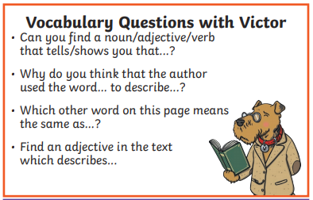
What does that word mean?
Can you put it in a different sentence?

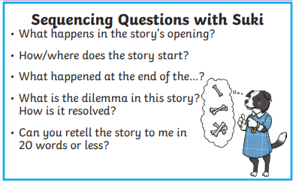
Can you summarise the story?
Can you draw a story road for the book?

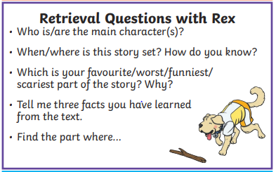

Remind them to use there sounds.
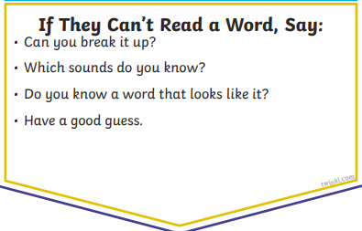
It might be a common exception word – one of their spellings!! I will attach these below

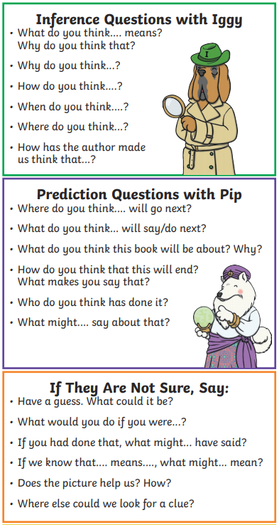

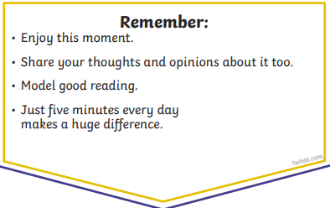

A further great skill to teach the children is allowing them to make links between books.

For example: Goldilocks and the three bears is similar to three little pigs because in both books there are three of one animal. Also, they are both short story fairytales.

Some recommended books for Year 2s:
Salty Dogs by Matty Long
Don’t look in this Book by Samuel Langley Smith
Gorilla Anthony Browne
The Day The Crayons Quit by Drew Daywalt
A Royal Lullabyhullaballoo
Mrs Wobble the Waitress
Roald Dahl – we have been reading Charlie and the Chocolate factory as a class!
Clarice Bean That’s Me – Lauren Child

