Year 1 maths home learning : Week 1
Task 1
This week we will be looking at money. Can you show your child the different coins and let them explore the similarities and differences between them e.g. some are bronze, some are silver, different shapes and different numbers on them? Talk to your child about the value of the coins.

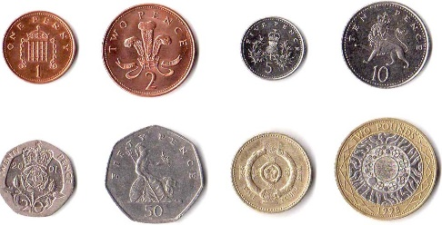

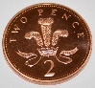
Begin by adding small amounts of the same coin together practically. (if you do not have many coins laying around you could always draw them and cut them out with your child. e.g.
2p + 2p + 2p = 6p
5p + 5p + 5p +5p = 20p

Challenge: Can your child use the 2p’s 5p’s and 10p’s to help them count in their 2, 5 and 10 times tables?
Then move onto to mixed coins
e.g
10p + 2p = 12p
15p + 2p + 1p = 18p

Interactive games to help with coin recognition and coin sorting:
https://www.topmarks.co.uk/money/toy-shop-money
https://www.topmarks.co.uk/money/coins-game

Task 2: Shop role play

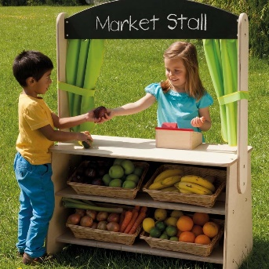

Role play is a great, fun and interactive way to help your child to learn. Have fun with your child setting up their own shop or snack/ tuck shop.

Ask your child to collect some items from around the house, this could be their toys, books etc or maybe some of their favourite food items (this would work well if you want to set up your own snack shop for your children while they are at home)

Make some labels for each item. Talk to your child about the coins they have explored and what price they think each item should be. Take turns with your child being the shopkeeper and the customer. Give your child some coins (remember you can make them if you do not have change to hand) take turns in buying and selling items. If you want to set up a snack shop with your child, they can buy the snacks they want throughout the day with the coins.

Key questions:
What coin/s are you going to use to buy that? Why?
Is there another coin/s you could use?
This is an opportunity to talk to your child about how different coins can make the same amount. For example, that 10 pennies are the same amount as a 10p coin etc and gives them the opportunity to explore how to make the same amount using different coins.
Have fun!
Task 3: Money problems

Give your child some real life money problems.
‘I have 15p but the snack I want costs 19p. how much more do I need?’
This will link to the missing number we have been working on recently. Encourage your child to count on from 15 to 19 to find the missing number or count out 15 objects or pennies and then count out 4 more to get to 19.

A box of pencils costs 30p
Can you show me all the ways you can make this amount with the different coins?
e.g. 10p + 10P + 10p = 30p
20p + 10p = 30P
20p + 5p + 5p= 30P

An apple cost 5p and a banana costs 12p. How much do they cost altogether?

Introducing notes
You may also want to introduce the use of bank notes and explore the that the value of these notes. You could explore how the value of the notes can be made up using different coins, explaining the reason we use notes is so we don’t have to carry lots of coins around all the time!
Other website links:
https://www.bbc.co.uk/bitesize/topics/zp8dmp3
Please remember that these activities are designed to be spread over the course of the whole week. The main aim of the tasks is to introduce the concept of money to your child and to have fun with them while they explore.

