Year R Reading Activities
Over the next few weeks, we have put together a range of reading books for your child to read at home.
The books can be accessed on the following website:
https://www.oxfordowl.co.uk/
To gain access to the books we have listed, please follow the instructions below:
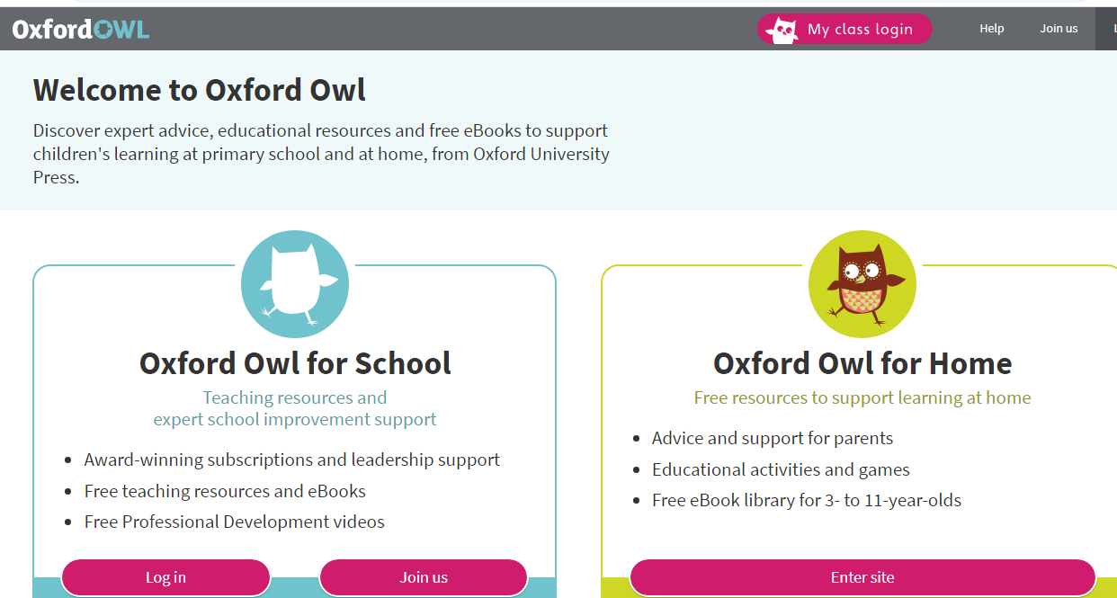
- Click on the My class login.
Class login details: Please login in using your child’s class name (case-sensitive)
SIhedgehogs
SIotters
SIsquirrels
Password for all: Shirley1

3. Click on My bookshelf
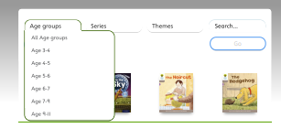

Each book chosen by the teachers will be suitable to your child’s current reading book. The Oxford Owl website also has interactive games and questions in addition to the guides set by school. Have fun!

Dark pink- ‘Fetch’ by Roderick Hunt and Alex Brychta
Pink 1- ‘Sun Hat Fun’ by Red Ditty
Pink 2- ‘Sun Hat Fun’ by Red Ditty
Red 1- ‘Quiz’ by Roderick Hunt and Alex Brychta
Red 2- ‘Toads in the Road’ by Roderick Hunt and Alex Brychta
Yellow- ‘Goal’ by Alison Hawes

