Parents
We have recently recapped our Phase 3 digraphs in phonics (see Phase 3 sound mat). We would like you go on a sound hunt around you house and find any items which have the following digraphs e.g coat for oa.
ai / ee / or / oa / ar
Please could you draw a picture of the items you have found in the table below.

Challenge
Can you write the name of the item you have found underneath your drawing?

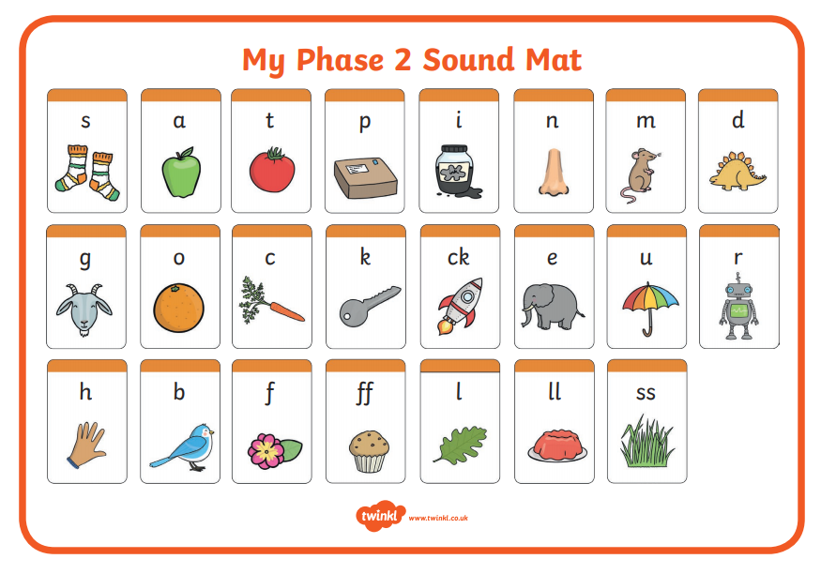

ai | ee | or | oa | ar

