Tricky

Three white rabbits where hopping down a narrow path and three grey rabbits were hopping up the same narrow path.

The only way they could pass is by jumping over each other, one at a time.

What is the smallest number of jumps needed before all the rabbits can continue along their path?

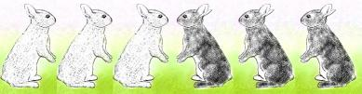

Questions to ask:
How can you record this?
What can you use to help you?
Will each colour jump the same number of hops?

Trickier

There are three baskets, a brown one, a red one and a pink one, holding a total of ten eggs.
The Brown basket has one more egg in it than the Red basket.
The Red basket has three fewer eggs than the Pink basket.
How many eggs are in each basket?

Questions to ask:
What can you use to help you?
Where do you need to start?

