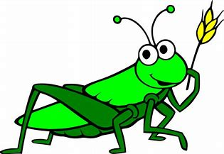
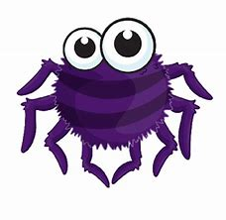
Year 1 English home learning
Week 11

This week we will be carrying on with our minibeast theme. Hopefully you will have had the chance to have a look at lots of different minibeasts while you were researching them last week. We will be using some of this information about minibeasts to create a poem.

Task 1
Log onto Oxford Owl and have a read of the book ‘Minibeast Poems’ with your child. These poems give lots of description so will help your child with their vocabulary choices when they come to describing their own minibeast.

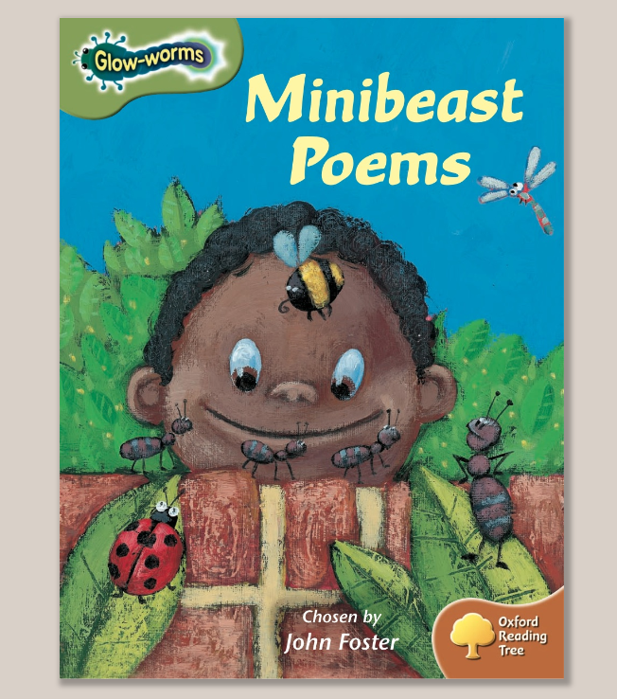

https://www.oxfordowl.co.uk/api/digital_books/1329.html

Task 2 – adjectives

Look at these pictures of the minibeasts. Can you describe and label them using lots of interesting adjectives? For example; brown, spikey legs, bright green wings and long, fury body If you want to describe the minibeast you researched last week or a different one, please feel free to. This activity is all about generating exciting vocabulary for your poem. You do not have to do all the minibeasts. You can magpie words and phrases from the Minibeast Poem book

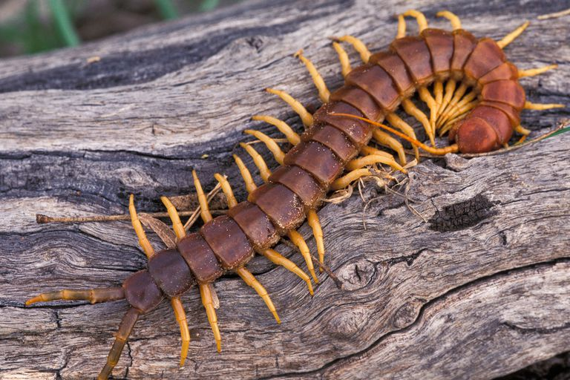

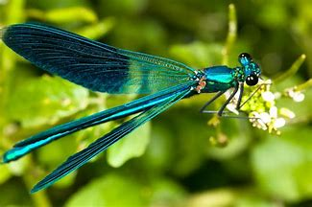

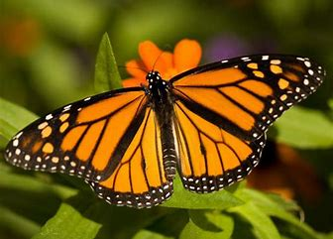

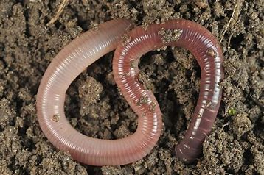
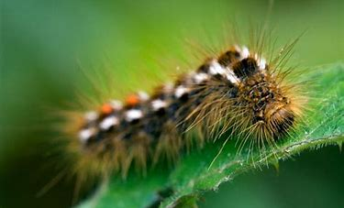

Task 3 -What am poem?

A what am I poem is a poem that gives descriptive clues about something (in this case a minibeast) so that the reader can try and guess what it is. To help with this activity take a look at the minibeast clue power point. You can then play a quick what am I game with your child. You can give clues about the minibeast and they must guess what it is and vice versa. Remember to make the clues quite vague at first to keep the reader guessing!
For a Poem like this we normally start a new line for every clue. You do not have to have verses but if you want to you could have a verse about what it looks like and maybe a verse about where it lives etc, but we do not teach this in Year 1. Here are some examples of what am I poems. You will be able to drag the blue box to reveal what minibeasts I have described. You can create this with a simple flap when your child decorates their poem. Remember your capital letter, full stops and lots of interesting adjectives!
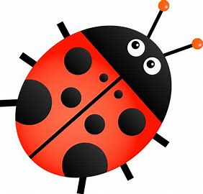

What am I?

I have two wobbly antennae to help me feel.
I have a long, thin body.
I have six skinny legs to help me move.
I like the smell of bright, pretty flowers.
I used to look very different.
I have two colourful wings to help me flutter around
What am I?

?
I am a butterfly
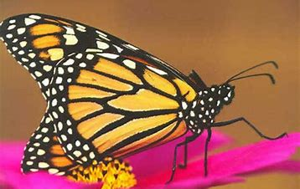

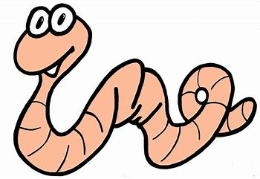
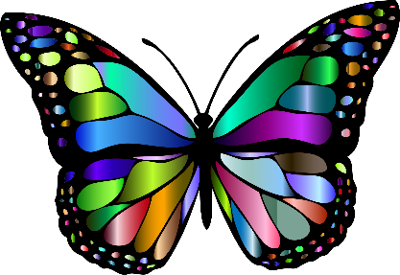

What am I?

I come in lots of different sizes.
I have eight googly eyes to watch your every move.
I have tiny hairs all over my body and legs.
I like to catch delicious flies and juicy bugs for dinner.
I am very good at making sticky silk.
I have eight long legs to help me crawl quickly.
What am I?

I am a spider
?
